**Problem 9:**

DELETE FROM LOCATION

WHERE LOCNO = ‘L108’;

**Snapshot for the Problem:**

1. **Before Updating the query**

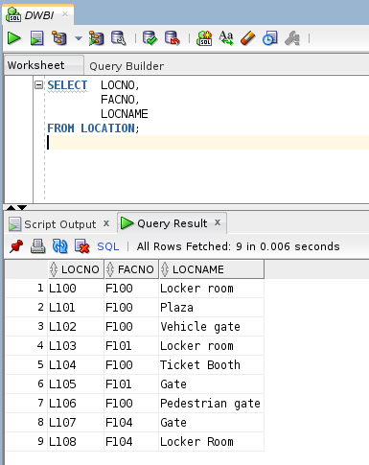

1. **Executing the Delete query**

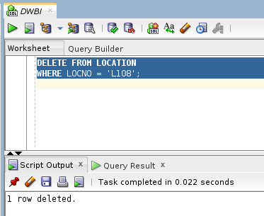

1. **After executing the query**